1 Year Bible—Revelation
Revelation is divided into 3 parts
B1 Messages to the Churches Chapters 1-3
B2 Messages of the Judgments Chapters 4-20
B3 Messages of Blessings Chapters 21-22

Introductory remarks
B1 There is a blessing for reading, studying, and believing this revelation.
C1 Revelation 1:3 WEB Blessed is he who reads and those who hear the words of the prophecy, and keep the things that are written in it, for the time is at hand.
C2 Revelation 22:14 WEB Blessed are those who do his commandments, that they may have the right to the tree of life and may enter in by the gates into the city.
B2 The purpose of this prophecy: Revelation 22:6-7 MKJV and he said to me, these sayings are faithful and true. And the Lord God of the holy prophets sent His angel to show to His servants the things which must shortly be done. 7 Behold, I come quickly. Blessed is he who keeps the sayings of the prophecy of this Book.
B3 There is a warning to those who tamper with the message.
C1 Revelation 22:18-19 BSB I testify to everyone who hears the words of prophecy in this book: If anyone adds to them, God will add to him the plagues described in this book. 19 And if anyone takes away from the words of this book of prophecy, God will take away his share in the tree of life and in the holy city, which are described in this book.
C2 Revelation 20:15 MKJV and if anyone was not found having been written in the Book of Life, he was cast into the Lake of Fire.

Messages to the Churches
B1To all the churches
C1 From the Lord Jesus
C2 From the Lord of the Church
C3 From the Lord Jesus the Ever-living God the Son: Revelation 1:17 WEB When I saw him, I fell at his feet like a dead man. He laid his right hand on me, saying, “Don’t be afraid. I am the first and the last,
B2 The other churches are summarized in the chart below. (Note, this chart is from a Roman Catholic teacher).

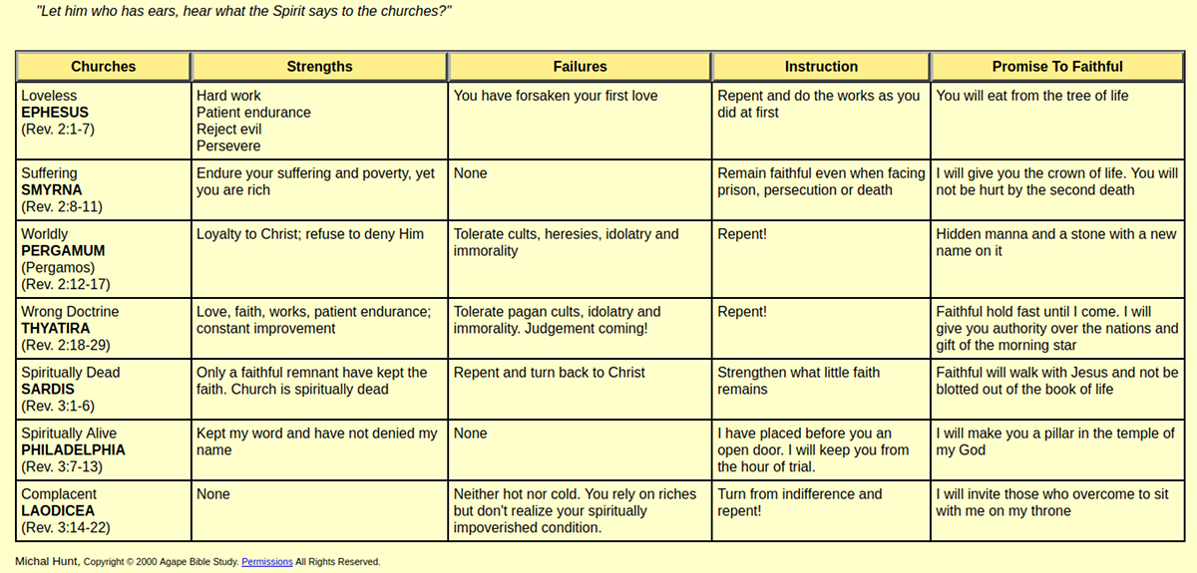
Messages of the Judgments
B1 3 sets of 7 Judgments
B2 First set—Seals
B3 Second set—Trumpets
B4 Third set—Vials/bowls
B5 The Lord Jesus Returns
C1 To fight evil and set up His kingdom (people do not set up His kingdom. Many teach this today).
C2 To imprison satan
C3 To judge at the Final Judgment
D1 This is the Great White Throne Judgment
D2 It is for all those who refused to believe the Gospel
D3 The Lake of Fire
Messages of Blessings
B1 New Jerusalem
B2 Paradise Restored

Things we can learn
B1 From the messages to the churches
C1 Jesus is Lord of all
C2 Jesus is Lord of the churches
C3 Jesus knows everything happening in each church
C4 Jesus knows everything happening in everyone
C5 Jesus knows what is wrong with a congregation and what is correct
C6 Jesus gives warning to repent from wrong
C7 Jesus gives encouragement to continue doing what is right
C8 Jesus is the standard of right and wrong
C9 Jesus has given us this standard in the Bible, in particular the New Testament
C10 Jesus holds each person accountable
C11 How to we measure to God’s standards?
D1 Mark 10:19 NLT but to answer your question, you know the commandments: 'You must not murder. You must not commit adultery. You must not steal. You must not testify falsely. You must not cheat anyone. Honor your father and mother.
D2 See Exodus 20: 12-16 and Deuteronomy 5:16-20.
D3 Deuteronomy 8:6 NET So you must keep his commandments, live according to his standards, and revere him.
B2 From the 3 sets of judgments
C1 God hates sin: Proverbs 15:9 ULB Yahweh hates the way of wicked people...
C2 God knows the sins each person does in thoughts, desires, words, and deeds:
D1 Knows: Luke 8:17 NLT for all that is secret will eventually be brought into the open, and everything that is concealed will be brought to light and made known to all.
D2 Most people think they are good: 1 John 1:10 CSB If we say, "We have not sinned," we make him a liar, and his word is not in us.
C3 God punishes sin: Romans 6:23 NLT for the wages of sin is death, but the free gift of God is eternal life through Christ Jesus our Lord.
C4 Most people, after being convicted by the Holy Spirit, spurn God’s offer of salvation: John 12:48 NLT but all who reject me and my message will be judged on the day of judgment by the truth I have spoken.
C5 Salvation is through grace alone through faith alone in Jesus Christ alone:
D1 Acts 4:12 NLT There is salvation in no one else! God has given no other name under heaven by which we must be saved.
D2 John 14:6 NLT Jesus told him, "I am the way, the truth, and the life. No one can come to the Father except through me.
B3 From the promises of God’s blessings
C1 There is a coming 1,000-year literal reign of Jesus Christ: Revelation 20:1-7.
C2 There is a final judgment: Revelation 20:11-15.
C3 There is a heaven and hell
D1 Heaven: Revelation 21.
D2 Hell: Revelation 20:10, 15 NLT Then the devil, who had deceived them, was thrown into the fiery lake of burning sulfur, joining the beast and the false prophet. There they will be tormented day and night forever and ever. ... 15 And anyone whose name was not found recorded in the Book of Life was thrown into the lake of fire.
C4 There is consciousness after physical death: Revelation 6:9-10 NLT When the Lamb broke the fifth seal, I saw under the altar the souls of all who had been martyred for the word of God and for being faithful in their testimony. 10 They shouted to the Lord and said, "O Sovereign Lord, holy and true, how long before you judge the people who belong to this world and avenge our blood for what they have done to us?
B4 From Scripture
C1 God creates. See Genesis 2.
C2 God blesses. See Genesis 2:3.
C3 God teaches. See Genesis 2:16-17.
C4 God tests. He may test directly by giving a command (1 Samuel 15:1-3) or through an agent (Genesis 3:1-7).
C5 God scores the test. For example 1 Samuel 15:13-33.
C6 God rewards for passing or failing His test
C7 God convicts of sin: John 16:8-11.
C8 God offers salvation:
D1 Matthew 11:28 NLT Then Jesus said, "Come to me, all of you who are weary and carry heavy burdens, and I will give you rest.
D2 1 Timothy 2:4 NIV who wants all people to be saved and to come to a knowledge of the truth.
C9 God warns Ezekiel 18:20 NLT the person who sins is the one who will die. The child will not be punished for the parent's sins, and the parent will not be punished for the child's sins. Righteous people will be rewarded for their own righteous behavior, and wicked people will be punished for their own wickedness.
C10 God judges: Romans 2:16 NLT and this is the message I proclaim—that the day is coming when God, through Christ Jesus, will judge everyone's secret life.
C10 God blesses for faith and obedience: 1 Corinthians 1:21 NKJV for since, in the wisdom of God, the world through wisdom did not know God, it pleased God through the foolishness of the message preached to save those who believe.
C12 God sentences and punishes for unbelief and disobedience: John 3:36 WEL He who believes in the Son has everlasting life, but he who refuses to believe the Son will not see life, on the contrary the fierce anger of God remains on him.
C13 How are we going to respond?
D1 Excuses?
D2 Blame shifting?
D3 Confession?
D4 Asking for forgiveness?
D5 Ignore?
C14 God’s promises are real and will happen

Further study
B1 Andy Woods
B2 Tony Garland
B3 Revelation at Precept Austin
B4 Charts
C1 A handy chart about the 7 Churches of Revelation
C2 Revelation Churches
C3 7 Churches Handout
C4 Seven Churches of Revelation (Roman Catholic site)

1 Year Bible—Revelation

Revelation, Jesus and Churches, Tribulation, Judgment, Salvation
Published by Choco on 8 Mar 20

